Dynamic Prompt Builder

Objective
The objective of this task was to understand how user input can be transformed into a structured AI prompt using a frontend application and a FastAPI backend.
This project demonstrates the concept of Prompt Engineering, where user-provided information is converted into a well-formatted prompt that can later be used by AI models such as ChatGPT, Gemini, Claude, or other Large Language Models (LLMs).

Technologies Used
• HTML
• CSS
• JavaScript
• FastAPI
• Python
• JSON

Project Overview
A Dynamic Prompt Builder application was developed.
The application allows users to enter:
• Project Name
• Skills Used
After clicking the "Generate Prompt" button, the frontend sends the information to the FastAPI backend. The backend formats the data into a structured prompt and returns it to the frontend for display.

System Architecture
User Input
↓
Frontend (HTML, CSS, JavaScript)
↓
POST Request
↓
FastAPI Backend
↓
Prompt Generation
↓
JSON Response
↓
Display Generated Prompt

Frontend Implementation
The frontend was developed using:
• HTML for structure
• CSS for styling
• JavaScript Fetch API for communication with the backend

Features
• Modern colorful user interface
• Gradient background design
• Responsive layout
• Project Name input field
• Skills input field
• Generate Prompt button
• Generated Prompt display section

Screenshot 1
User Interface
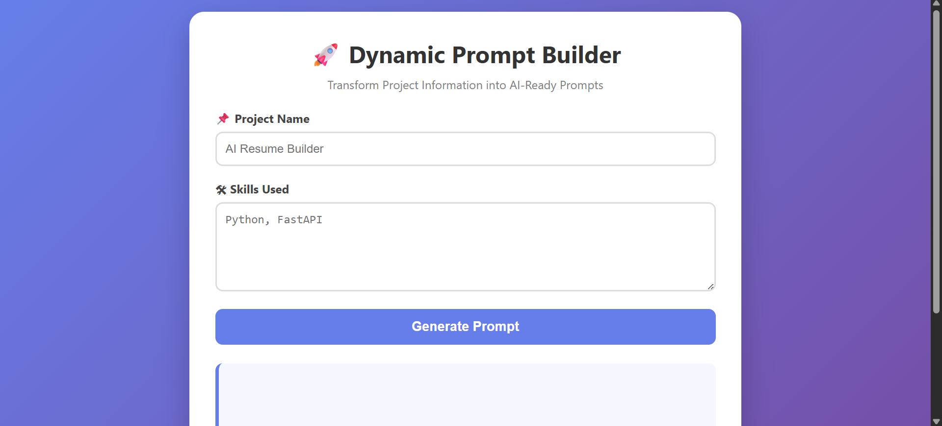

Screenshot 2
Backend Source Code
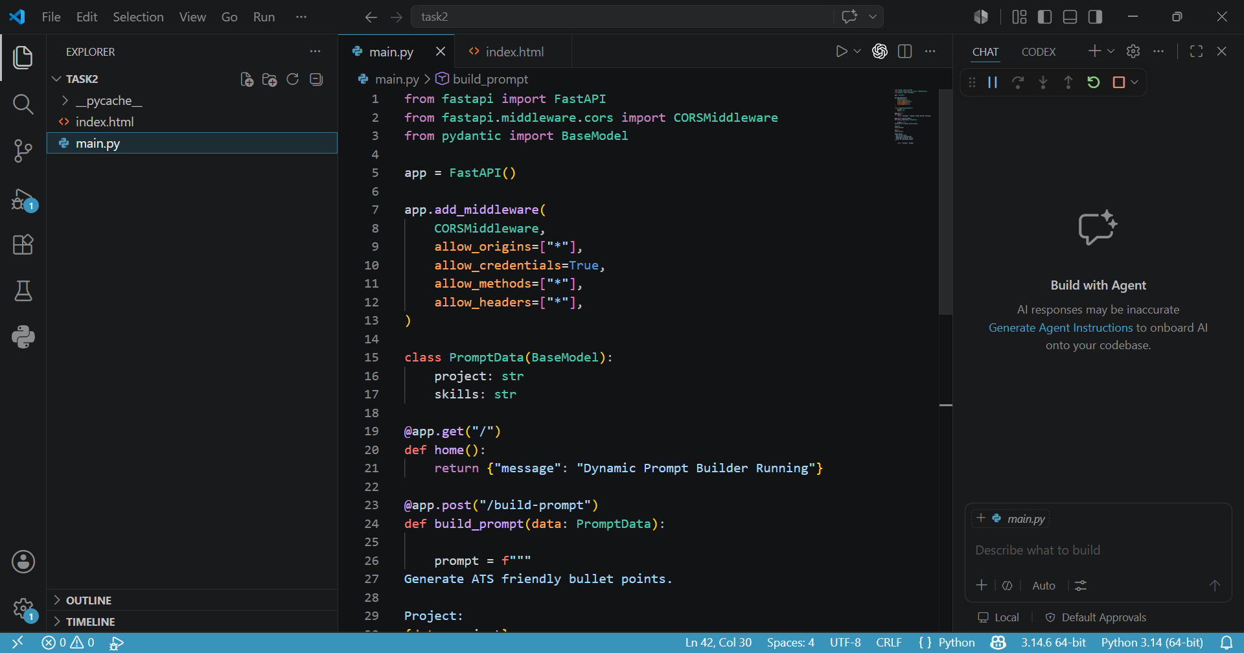
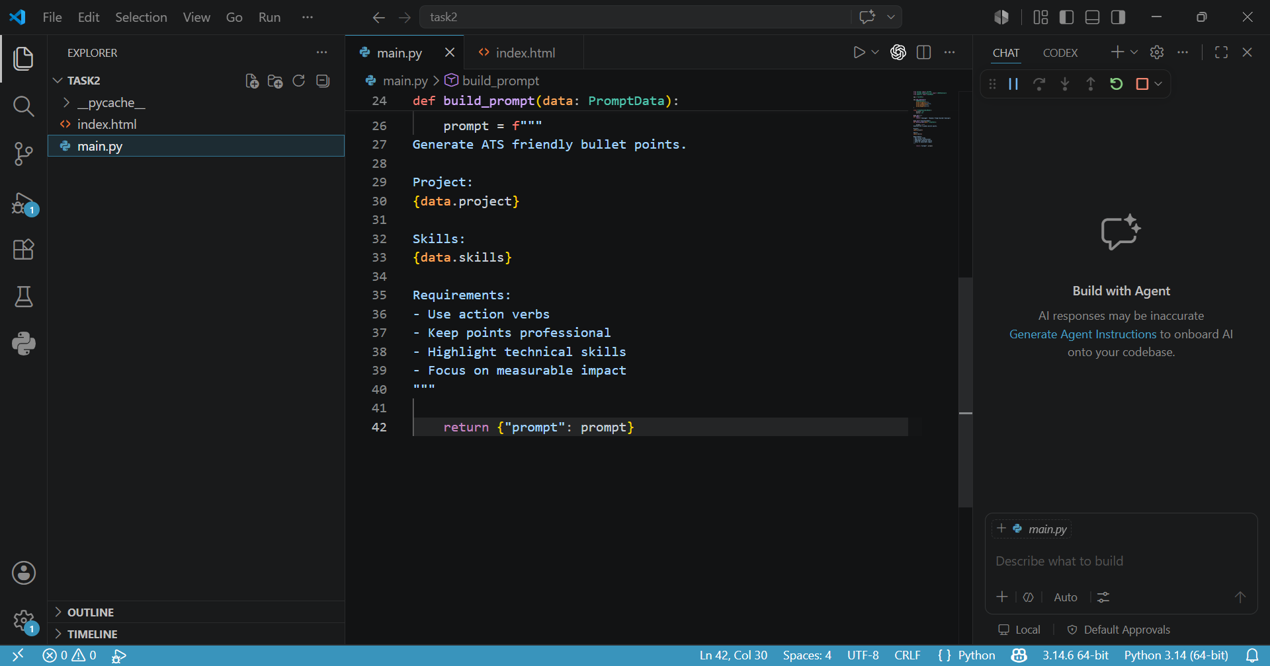

Screenshot 3
Swagger API Documentation
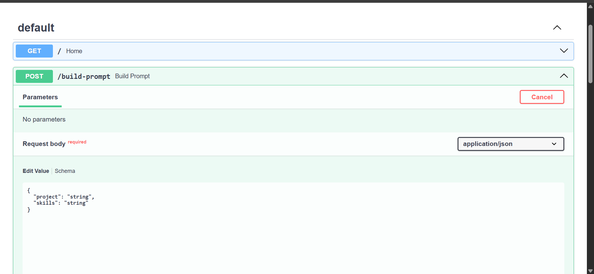

Screenshot 4
Successful API Response
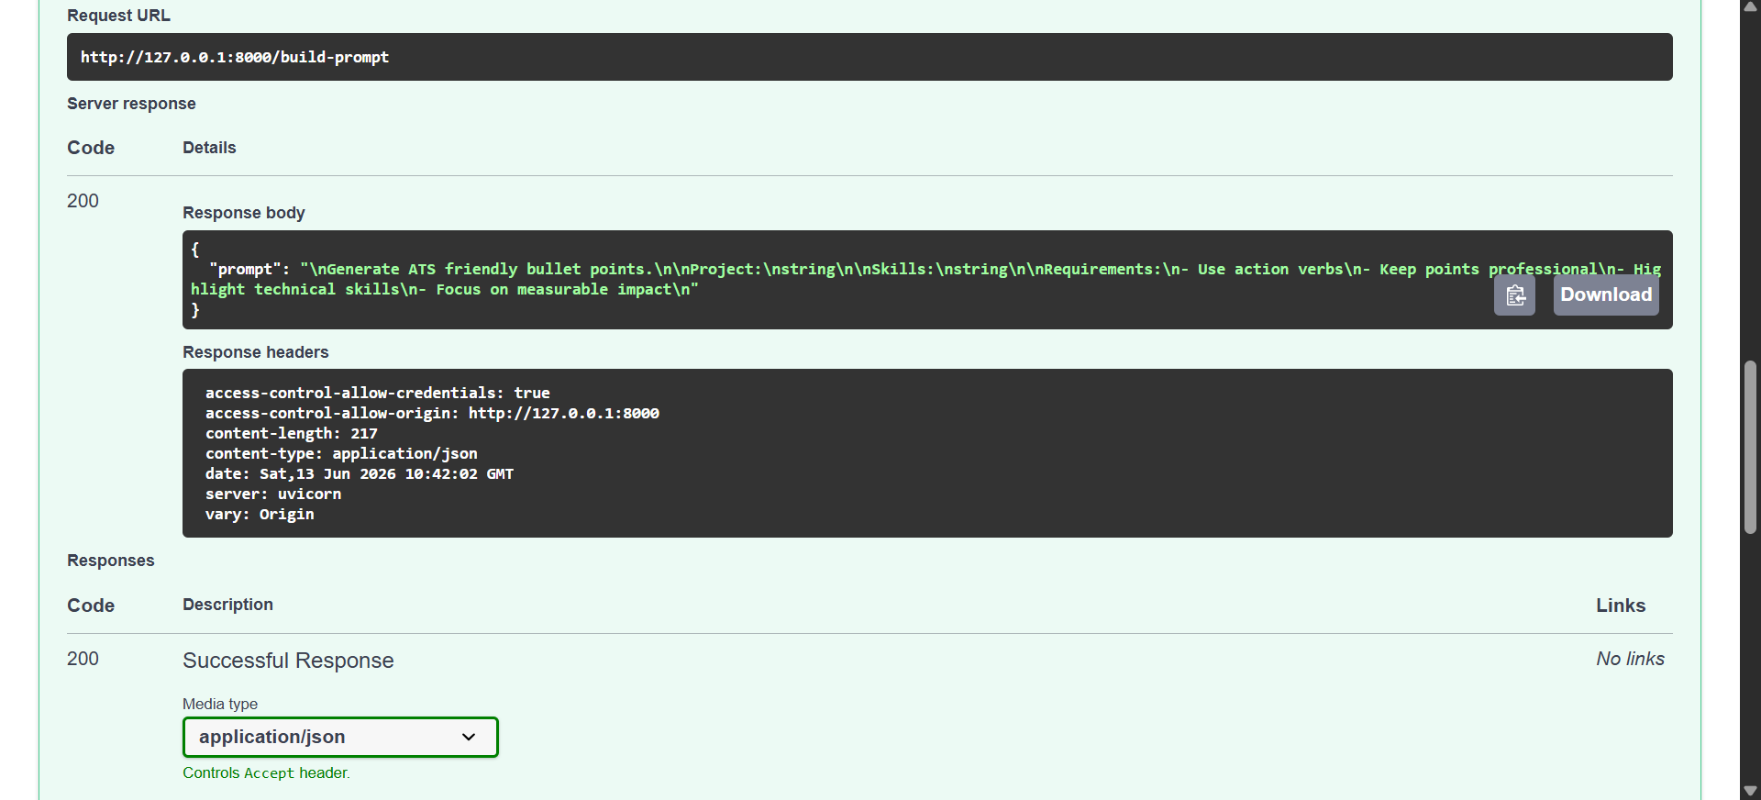

Screenshot 5
Generated Prompt Display
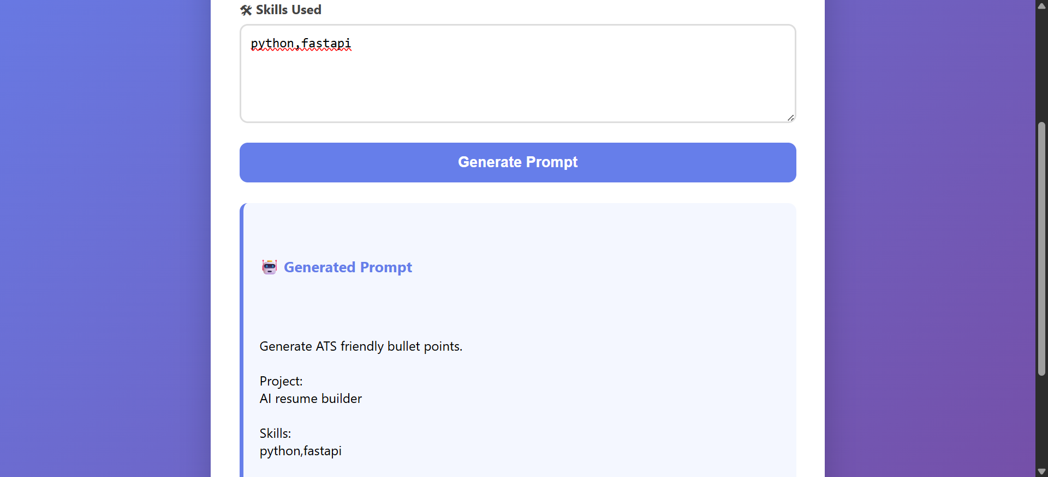

Screenshot 6
Application Running in Terminal
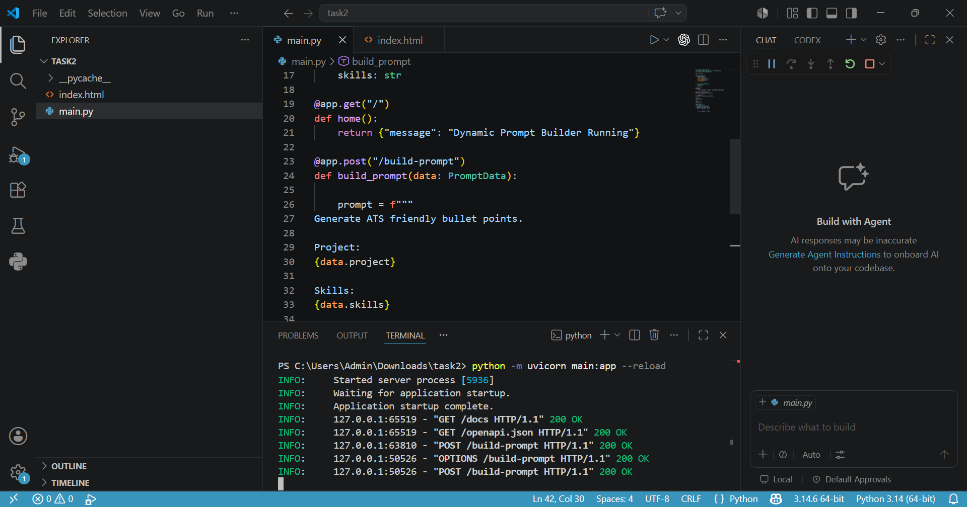

Working Process

Step 1
User enters Project Name and Skills.

Step 2
Frontend sends a POST request to the backend.

Step 3
FastAPI receives the JSON data.

Step 4
Backend dynamically generates a prompt template.

Step 5
Prompt is returned as a JSON response.

Step 6
Frontend displays the generated prompt.

Sample Input
Project Name:
AI Resume Builder
Skills:
Python, FastAPI

Generated Prompt
Generate ATS friendly bullet points.
Project:
AI Resume Builder
Skills:
Python, Fastapi

Learning Outcomes
Through this project, the following concepts were learned:
• Client-Server Architecture
• FastAPI API Development
• JSON Request and Response Handling
• JavaScript Fetch API
• Dynamic Data Processing
• Prompt Engineering
• Prompt Templates
• Frontend and Backend Integration
• API Testing using Swagger

Importance of Prompt Engineering
AI models perform better when provided with structured prompts.
Instead of sending raw user input directly to an AI model, applications first convert the data into a well-defined prompt.
This project demonstrates the first step in building AI-powered applications by generating prompts dynamically from user input.

Conclusion
The Dynamic Prompt Builder successfully converts user input into a structured AI-ready prompt. The project demonstrates how frontend applications communicate with backend services and how prompt engineering can be implemented before integrating real AI models. This serves as a foundation for future AI-powered applications such as Resume Builders, Chatbots, and Content Generation Systems.

